**Sampling and Reconstruction of a Signal**

**AIM:**

1. To perform sampling of given analog signal and reconstruct it by simulation.
2. Also, plot the frequency spectrum of every signal.

**THEORY:**

The Fourier transform of the original signal yields the frequency spectrum of the signal. For sampling, the original signal is multiplied with an impulse train. Sampling is carried out in this way. This is followed by the application of low pass filter to the sampled signal in frequency domain. Here, we obtain a signal whose inverse Fourier transform gives us the reconstructed signal.

**ALGORITHM:**

* Cosine signal of a particular frequency is generated using ‘cos’ function.
* The frequency spectrum of this signal is obtained by Fourier transform using ‘fft’ and ‘fftshift’.
* Impulse train is constructed in time domain.
* Again, frequency spectrum of the impulse train is obtained.
* In time domain, impulse train and the original signal are multiplied to obtain sampled signal using elementwise multiplication.
* Frequency spectrum of this signal is obtained.
* Low pass filter is constructed in frequency domain and multiplied with the above frequency spectrum.
* The inverse Fourier transform of this yields the reconstructed signal using ‘ifftshift’ and ‘ifft’.

**PROGRAM:**

clc;

close;

clear;

f1=100;

t=-10:(1/f1):10

fa=1;

*//Original signal*

x=cos(2*%pi*fa*t);

subplot (331)

plot (t, x);

xlabel ('time, t')

ylabel('cos(2*pi*fa*t)')

title ('Original signal')

df=(f1/length(t));

f=(-f1/2):df:(f1/2-df)

y1=fftshift(fft(x)); *//Fourier transform of original signal*

subplot (332)

plot (f, abs(y1))

xlabel ('freq, f')

ylabel('Magnitude')

title ('Frequency spectrum of original signal')

*//Impulse train*

n=length(t);

fs=10;

d(1:(f1/fs): n) =1

subplot (333)

plot (t, d)

xlabel ('time, t')

ylabel('Magnitude')

title ('Impulse train')

*//Frequency spectrum of impulse train*

y2=fftshift(fft(d));

subplot (334)

plot (f, y2)

xlabel ('freq, f')

ylabel('Magnitude')

title ('Frequency spectrum of Impulse train')

*//Sampled signal*

s=x.*d';

subplot (335)

plot (t, s)

xlabel ('time, t')

ylabel('Magnitude')

title ('Sampled signal')

*//frequency spectrum of sampled signal*

y3=fftshift(fft(s));

subplot (336)

plot (f, y3)

xlabel ('freq, f')

ylabel('Magnitude')

title ('Frequency spectrum of Sampled signal')

*//Low pass filter*

r=zeros (1, length(f));

for i=1:1: length(f)

if(f(i)>=-fa && f(i)<=fa)

r(i)=1;

end

end

subplot (337)

plot (f, r)

xlabel ('freq, f')

ylabel('Magnitude')

title ('Low pass filter')

y4=r.*y3;

subplot (338)

plot (f, y4)

xlabel ('freq, f')

ylabel('Magnitude')

title ('Frequency spectrum')

*//Reconstructed signal*

y5=ifftshift(ifft(y4));

subplot (339)

plot (f, y5)

xlabel ('time, t')

ylabel('Magnitude')

title ('Reconstructed signal')

**RESULT:**

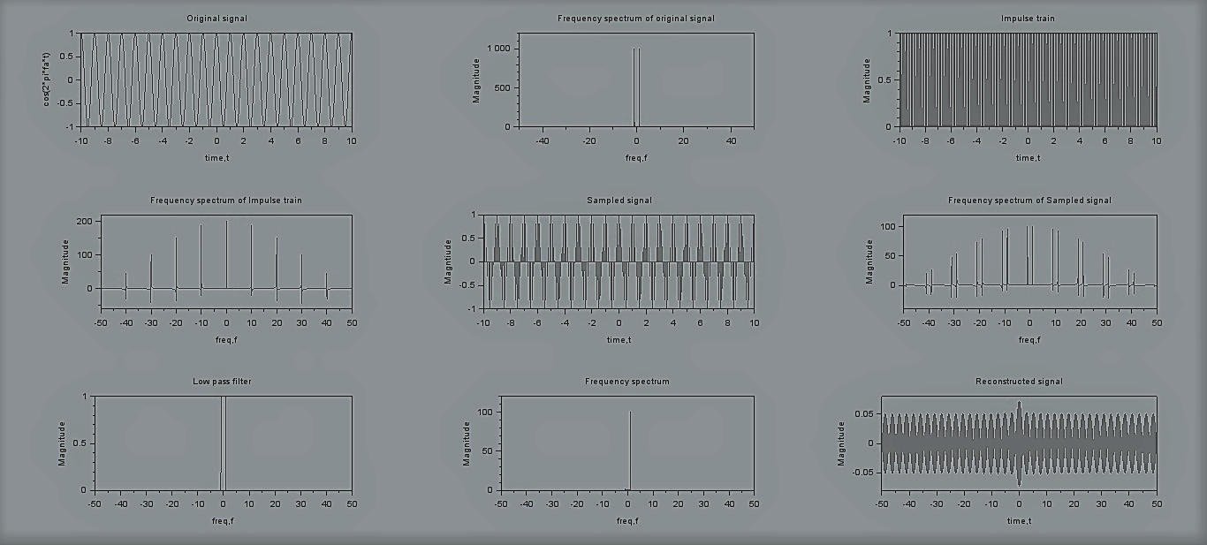

**CONCLUSION:**

Hence, we have successfully sampled and reconstructed the given analog signal while, plotting the frequency spectrum of each signal.

**SAMPLING AND RECONSTRUCTION OF SIGNAL**

**Aim: Study of Sampling and Reconstruction of signal. Verify Nyquist criteria. Model ST21O1 W kit, connecting wires, CRO/DSO**

**Apparatus:** Model ST 2151 W kit, connection wires, CRO/DSO

**Sampling Theory:**

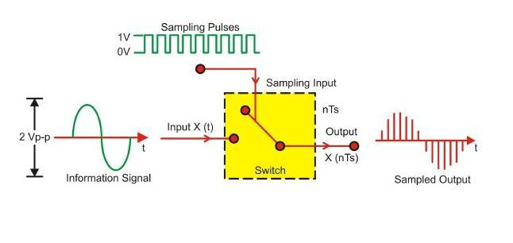

**Procedure:**

**A. Set up for Sampling and reconstruction of signal.**

Initial set up of trainer:

Duty cycle selector switch position: Position 5

Sampling selector switch: Internal position

1. Connect the power cord to the trainer. Keep the power switch in ‘Off’ position.
2. Connect 1 KHz Sine wave to signal Input as shown in Fig.1.1.
3. Switch ‘On’ the trainer's power supply & Oscilloscope.
4. Connect BNC connector to the CRO and to the trainer’s output port.

You can observe the process of step-by-step generating sine wave signal from Square wave of 1 KHz at TP3, TP4, TP5 and TP6 respectively.

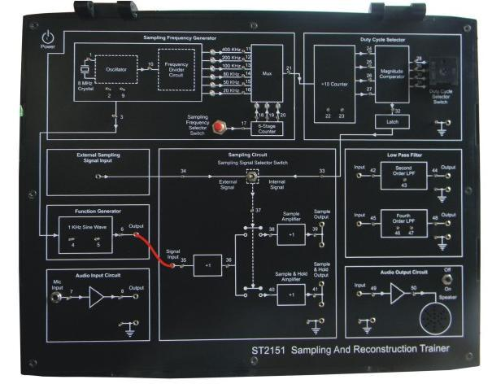

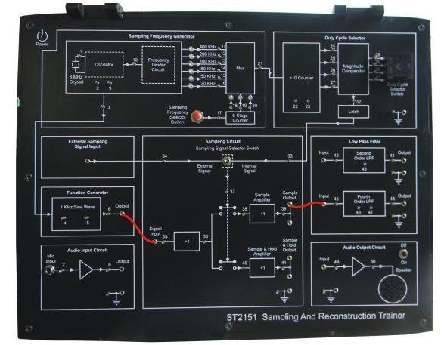Fig. 1.1. Connection diagram for sampling a signal

Fig. 1.2. Connection diagram for reconstruction of a sampled signal

**B**. **Set up for effect of Sample Amplifier and Sample and Hold Amplifier on reconstructed signal.**

**Set up for effect of II order and IV order Low Pass Filter on reconstructed signal.**

Initial set up of trainer:

Duty cycle selector switch position: Position 5

Sampling selector switch: Internal position

1. Connect the power cord to the trainer. Keep the power switch in ‘Off’ position.
2. Connect 1 KHz Sine wave to signal Input.
3. Switch ‘On’ the trainer's power supply & Oscilloscope.
4. Connect BNC connector to the CRO and to the trainer’s output port.
5. Select sampling frequency of 8 KHz by Sampling Frequency Selector Switch pressed till
6. KHz signal LED glows.
7. Observe 1 KHz sine wave and Sample Output (TP39) on oscilloscope. The display shows

1 KHz sine wave being sampled at 8 KHz, so there are 8 samples for every cycle of the sine wave.

1. Connect Sample Output to Fourth Order low pass filter Input as shown in figure 1.2. Observe the filtered output (TP48) on the oscilloscope. The display shows the reconstructed 1 KHz sine wave.
2. Similarly observe the sampled 1 KHz sine wave at and Sample and Hold Output (TP41) on oscilloscope. The display shows 1 KHz sine wave being sampled and hold signal at 8 KHz. Connect Sample and Hold Output to Second Order low pass filter Input and observe the filtered output (TP44) on oscilloscope. The display shows the reconstructed1 KHz sine wave.
3. By pressing Sampling Frequency Selector Switch change the sampling frequency from 2 kHz, 5 kHz, 10 kHz, 20 kHz up to 40 kHz. (Sampling frequency is 1/10th of the frequency indicated by illuminated LED). Observe how Sample output (TP39) and Sample and Hold output (TP41) changes in each case.

**Sample Observations:**

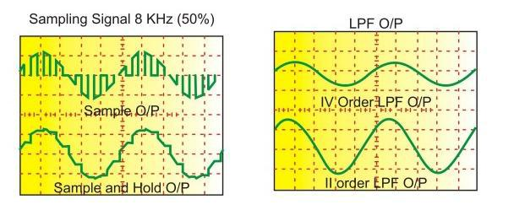

**Observation Table:**

**a: Natural Sampling b: Sample n Hold i: 2nd order ii: 4th order**

|  |  |  |  |  |
| --- | --- | --- | --- | --- |
| **Sampling Frequency (kHz)** | **Sampling** |  | **Reconstruction** |  |
|  | **Frequency (Hz)** | **Peak-Peak Voltage (V)** | **Frequency (Hz)** | **Peak-Peak Voltage (V)** |
| 20 | a)1k | 4.48 | i)1k | 4.88 |
|  |  |  | ii)1k | 4.72 |
|  | b)1k | 4.88 | i)1k | 6 |
|  |  |  | ii)1k | 5.36 |
| 50 | a)999.35 | 4.4 | i)999.36 | 3.6 |
|  |  |  | ii)999.36 | 2.86 |
|  | b)999.36 | 4.8 | i)999.35 | 5.04 |
|  |  |  | ii)999.35 | 4.76 |
| 80 | a)999.36 | 4.7 | i)999.35 | 3.22 |
|  |  |  | ii)1.12k | 2.52 |
|  | b)1000.6 | 5.04 | i)999.37 | 5.32 |
|  |  |  | ii)999.38 | 4.92 |
| 100 | a)1k | 4.48 | i)1k | 2.8 |
|  |  |  | ii)1k | 2.82 |
|  | b)1k | 4.88 | i)1k | 5.72 |
|  |  |  | ii)1k | 4.84 |
| 200 | a)1.14k | 4.36 | i)1k | 2.36 |
|  |  |  | ii)1k | 2.36 |
|  | b)1k | 5 | i)1k | 5.68 |
|  |  |  | ii)1k | 4.92 |
| 400 | a)1k | 4.64 | i)1k | 3.2 |
|  |  |  | ii)1k | 2.32 |
|  | b)1k | 4.92 | i)1k | 4.62 |
|  |  |  | ii)1k | 4.92 |

**Output Waveforms:**

f = 50Hz f = 80Hz

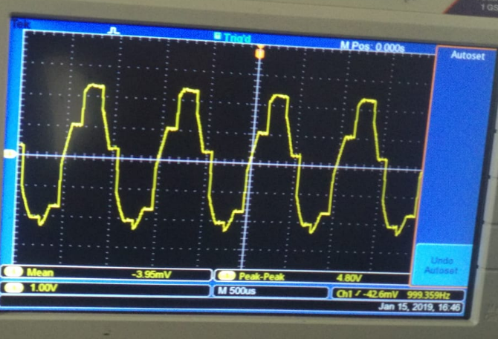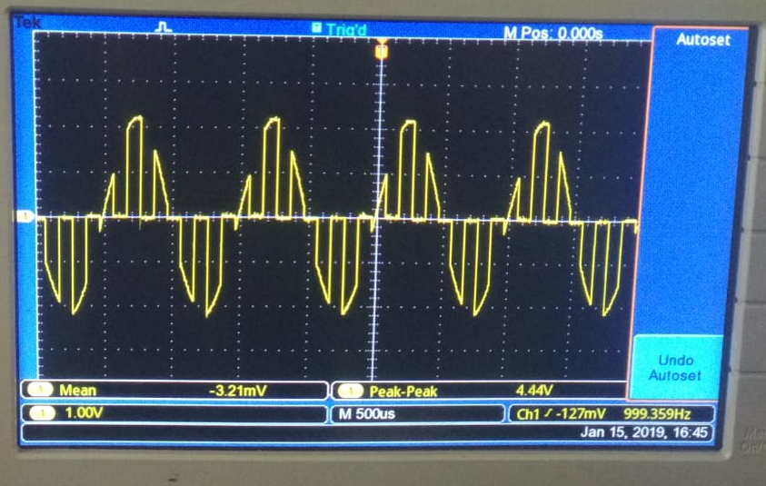

Sample Sample & Hold

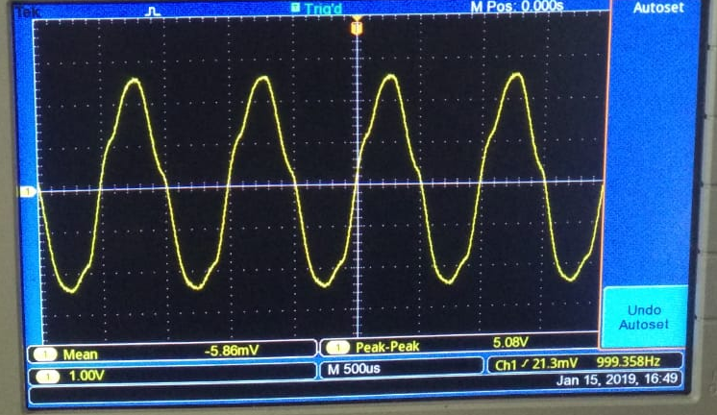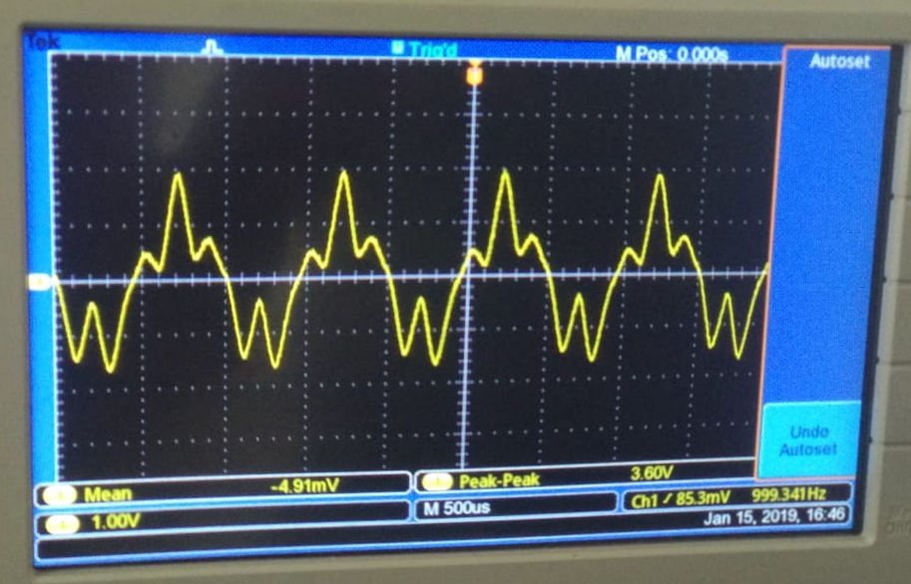

2nd order LPF reconstruction 2nd order LPF reconstruction

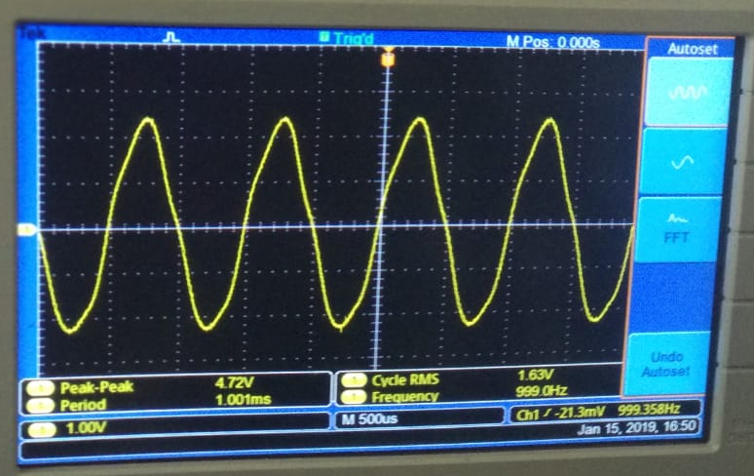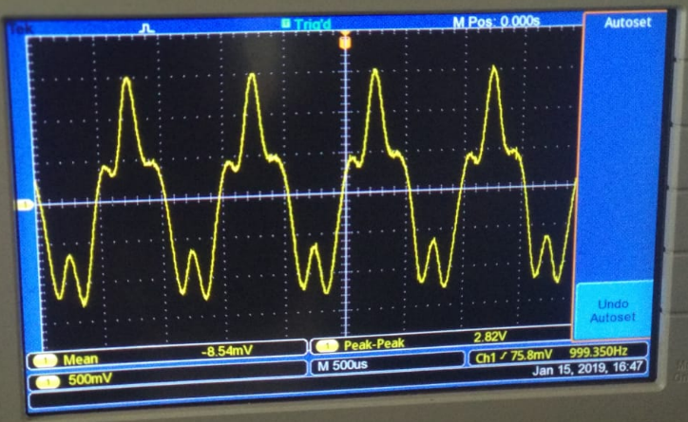

4th order LPF Reconstruction 4th order LPF Reconstruction

**Conclusion:** Thus Sampling and Reconstruction of Signals was performed successfully using Sampling Kit.

**Remarks:** **Signature:**